2019 Aboriginal Scholarship recipient: Larissa Perry (Telethon Kids Institute)

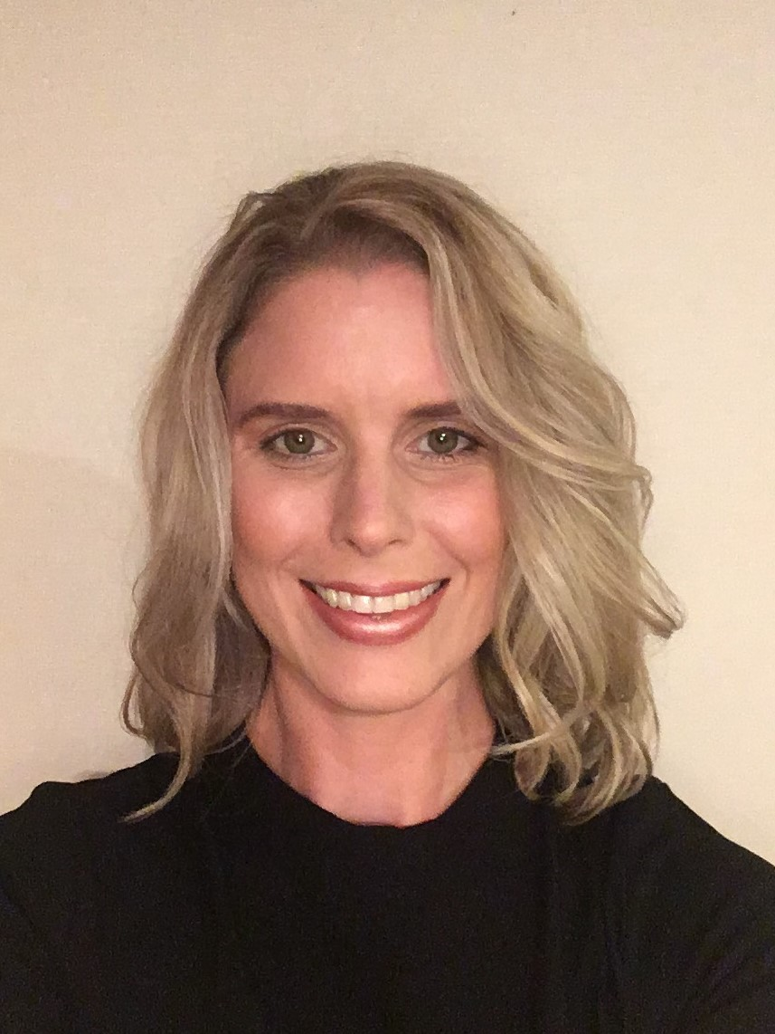

Brief History of Myself
I had previously worked within the iron ore, and oil and gas sector prior to being a stay at home mum to my two daughters for the past few years. I had always aspired to work within the health sector, particularly in the area of Aboriginal and Torres Strait Islander health, child and adolescent health and/or women’s health; therefore, I changed careers by completing a Bachelor of Health Science degree (majoring in Health Promotion and Addiction Studies) at Edith Cowan University (ECU) in 2017. I am currently completing a Bachelor of Health Science Honours degree at ECU to gain skills and knowledge in health research. I had applied for the Australian Health Promotion Association scholarship to gain further experience, knowledge and skills in health promotion and research within a reputable organisation.

Summary of Scholarship Project
My scholarship project, Empower Parents/Carers to Improve Cultural Security will be part of the broader Ngulluk Koolunga Ngulluk Koort (Our Children, Our Heart) project, and will incorporate the recommended principles and practices. I will conduct a mixed methods study on the experiences and attitudes of parents/carers (i.e., Mothers, Fathers, Grandparents, Aunties, Uncles, older siblings, foster/adoptive parents) towards the cultural awareness, safety and security of early education settings (Early childhood education and care, Kindergarten, Preschool and Year One) for young Aboriginal children. I will conduct focus groups and survey discussions with parents/carers to obtain relevant and sufficient data to develop and report on a health promotion resource. Also, I will measure whether there is an improvement in the confidence of parents/carers in discussing cultural concerns with their child’s teacher, principal and the P&C members, and assess the quality and acceptability of the health promotion resource via pre- and post-intervention assessments.

The overall goal of this project is to empower parents/carers who currently have young Aboriginal children enrolled in early education settings to improve the cultural security of these environments. The knowledge generated by the project will describe an early education setting that promotes good mental health and wellbeing, and by being culturally safe, socially inclusive and aiding connectedness for young Aboriginal children. Improving the cultural security of early education settings will promote positive mental health, social inclusion and connectedness.

