2019 Graduate Scholarship recipient: Courtney King (Telethon Kids Institute)

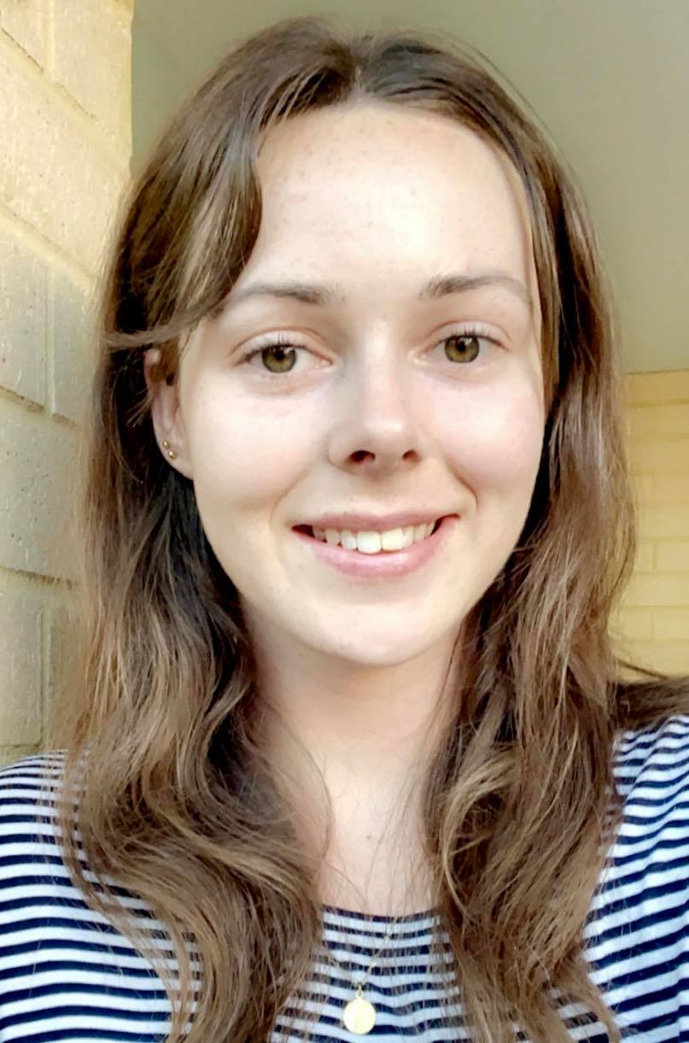

Brief History of Myself
I grew up in the regional town of Esperance and after graduating from high school I relocated to Perth to commence my university studies at Curtin University. I initially began studying interior architecture but quickly realised my passions lied elsewhere. This lead me to enrol in health promotion as being raised within a very health conscious family I was eager to enter the health sector and support others in improving their health. Whilst studying and volunteering my desire to work within the areas of alcohol and other drugs, sexual health and/or adolescent health grew. I have now recently completed my Bachelor of Health Science (Health Promotion) degree at the end of 2018 and am eager to step into the health promotion workforce and gain the valuable knowledge and skills this opportunity will provide me with.

Summary of Scholarship Project
I will be working within the Health Promotion and Education Research team at the Telethon Kids Institute, extending the current Let Me Know (LMK) project - a school-based intervention being developed and trialled for parents of year 7 students, addressing underage alcohol consumption. I will therefore be conducting formative research into an additional age group of parents of year 9 and 10 students to provide the direction for adapting the LMK project and ongoing support for parents as their children age. This formative research will explore the unique challenges parents of year 9 and 10 students face in relation to underage alcohol consumption and identify the appropriate adaptions required to suit this additional target group.

Phase 1 of my project will consist of a literature review of attitudes; behaviours, enablers and barriers followed by a scoping review of existing Australian interventions in Phase 2. Phase 3 will then involve conducting focus groups and interviews with the target group, key stakeholders and alcohol and other drug researchers. In Phase 4 I will draw upon the findings from the first three phases to develop a conceptual model for the targeted behaviour and develop a framework for the proposed intervention. Overall, this project aims to address underage alcohol consumption and empower parents in delaying and reducing their children’s drinking behaviours.

